Case study: Before coding of the website, planning is important, students should visit different websites (Min. 5) for the different client projects and note down the evaluation results for these websites, either good website or bad website in following format:

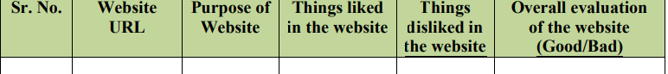

From the evaluation, students should learn and conclude different website design issues, which should be considered while developing a website.

**Sr. No 1**

**Website URL :** [https://www.narendradwivedi.org](https://www.narendradwivedi.org/)

**Purpose Of Website :** Coding Solutions & Articles Related To Programming, Ethical Hacking & Reverse Engineering

**Things Liked In The Website :**

* User Interface
* Day/Dark Mode Available
* Interactive

**Things Disliked In The Website :**

* No Automatic Dark/Day Theme Switching According To Time
* No Live Chat Support

**Overall Evaluation Of The Website :** Good

**Sr. No 2**

**Website URL :**https://www.pcmag.com

**Purpose Of Website :** Provide Reviews Of Applications , Games & Gadgets

**Things Liked In The Website :**

* User Interface
* Content

**Things Disliked In The Website :**

* Blank Space After Footer**Overall Evaluation Of The Website :** Good

**Sr. No 3**

**Website URL :** https://github.com

**Purpose Of Website :** Provide Space For Hosting Codes & Applications

**Things Liked In The Website :**

* Easy To Explore Codes
* Search Feature

**Things Disliked In The Website :**

* Home Page Lags On Low End Devices

**Overall Evaluation Of The Website :** Good

**Sr. No 4**

**Website URL :** https://stackoverflow.com

**Purpose Of Website :** Question & Answer Website For Programmers

**Things Liked In The Website :**

* Interactive
* Easy To Copy Codes

**Things Disliked In The Website :**

* No Dark Mode

**Overall Evaluation Of The Website :** Good

**Sr. No 5**

**Website URL :** https://www.quora.com

**Purpose Of Website :** Question Answer Forum Type Website Related To Everything

**Things Liked In The Website :**

* User Interface
* Color Combination

**Things Disliked In The Website :**

* Text Advertisements Between Answers
* Asks To Subscribe To View Top Answers

**Overall Evaluation Of The Website :** Good